END TO END DATA ENGINEERING PROJECT
ADLS + ADF + DATABRICKS + VISUALIZATION
Business Requirements:
Our company is working with retail clients and handling their transactional data.
The business team aims to analyze overall performance using this data.
They have defined multiple key metrics that need to be tracked and measured to evaluate sales, revenue trends, and customer behavior effectively.
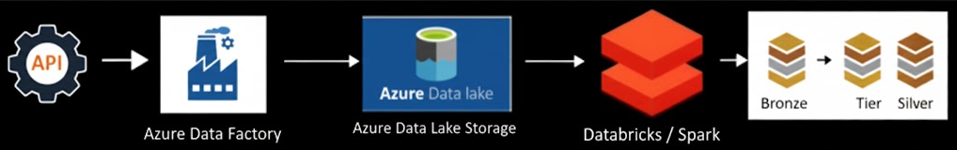

BUSINESS METRICS
- Daily Revenue & Purchases
- Revenue by Payment Method
- Store Performance
- Loyalty Level Revenue Contribution
- Product Category Sales
Created- Storage acoount and created container
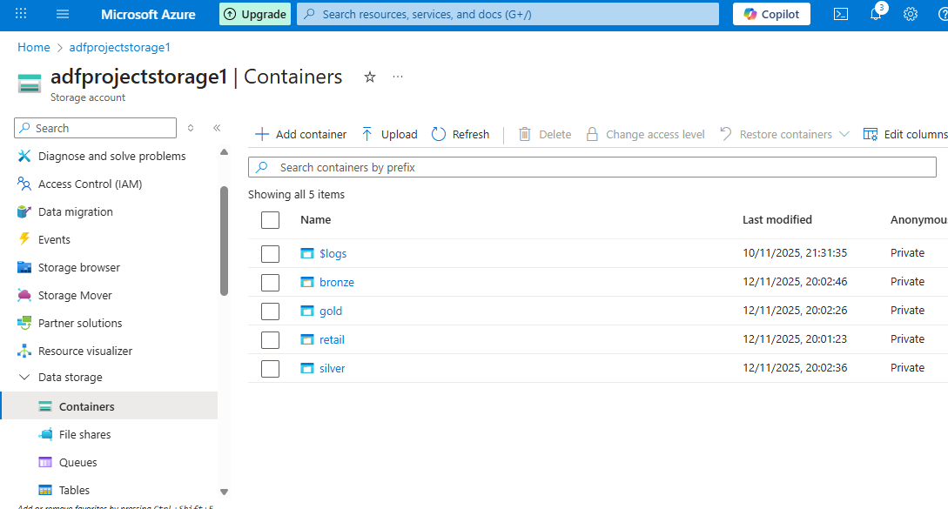
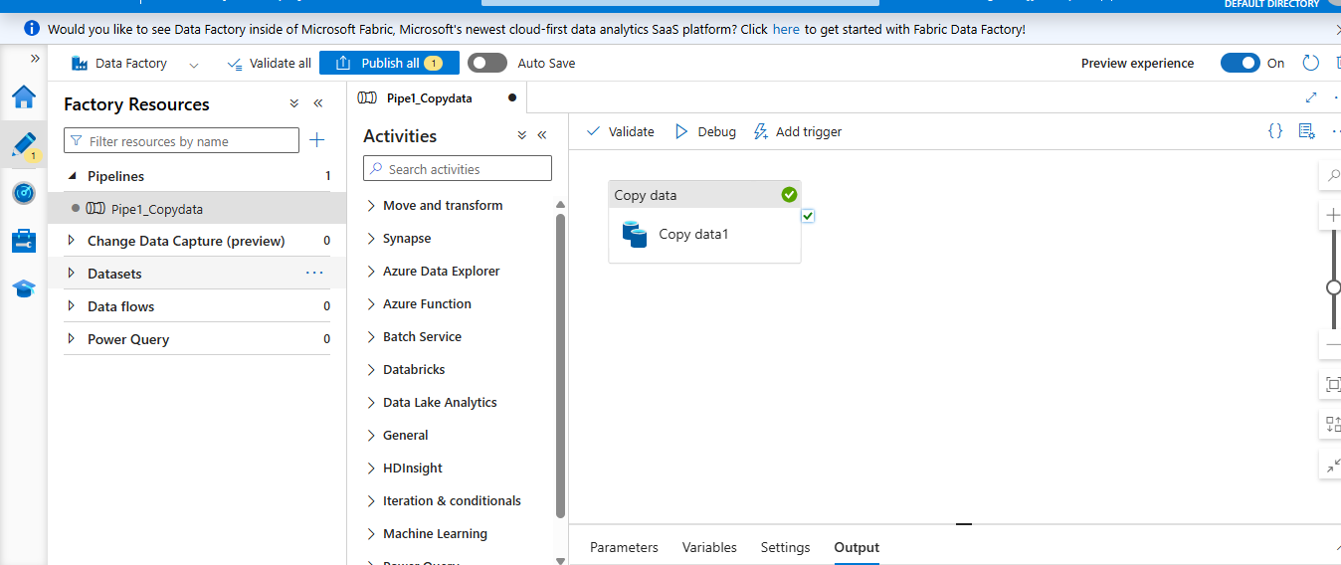

Created pipeline and sink the data with (http to adls storage ) data loaded in parquet File
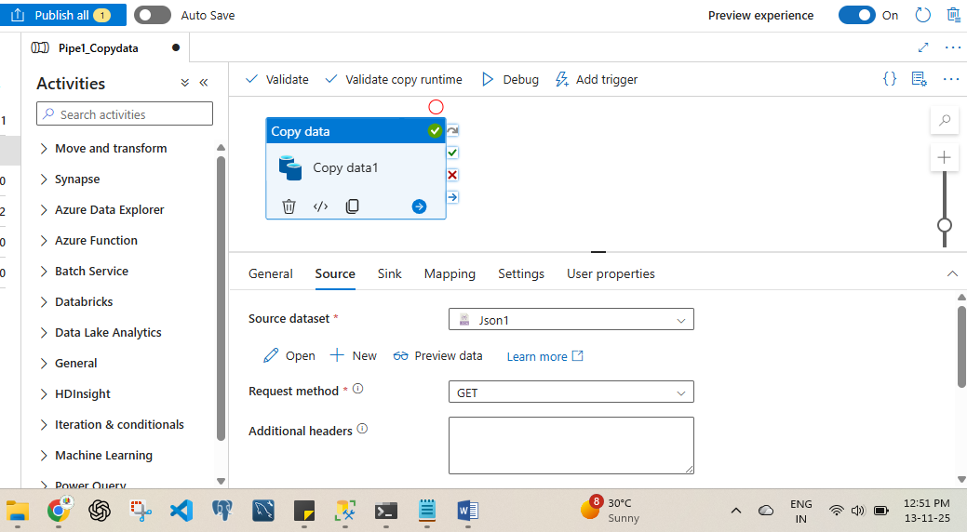
Using DATABRICKS ,Pyspark and SQL in notebook
Cleaned the file data and Created filter
Using python , pyspark, sql
Using access key and file location first we access the location then created parquet file
